**CS401_LAB 8**

**Program output for LAB 8**

**Part 1**

linked list and sorted list implementation

**Output**

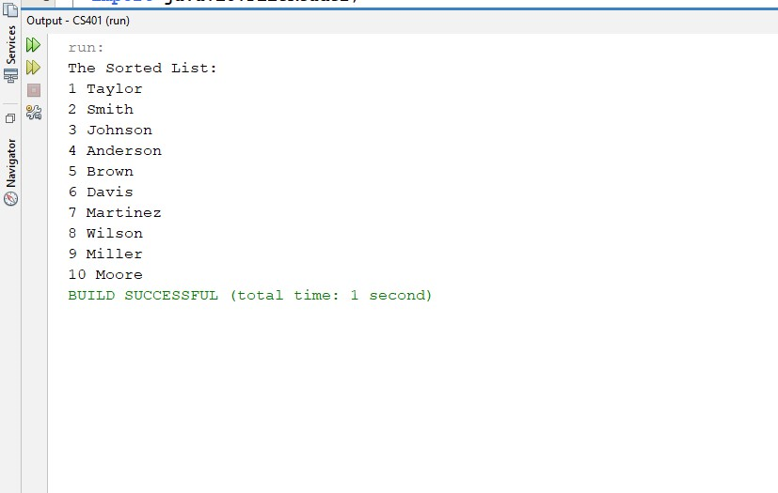

**Part 2**

Circular linked list implementation with add, remove and contains method

**Output**

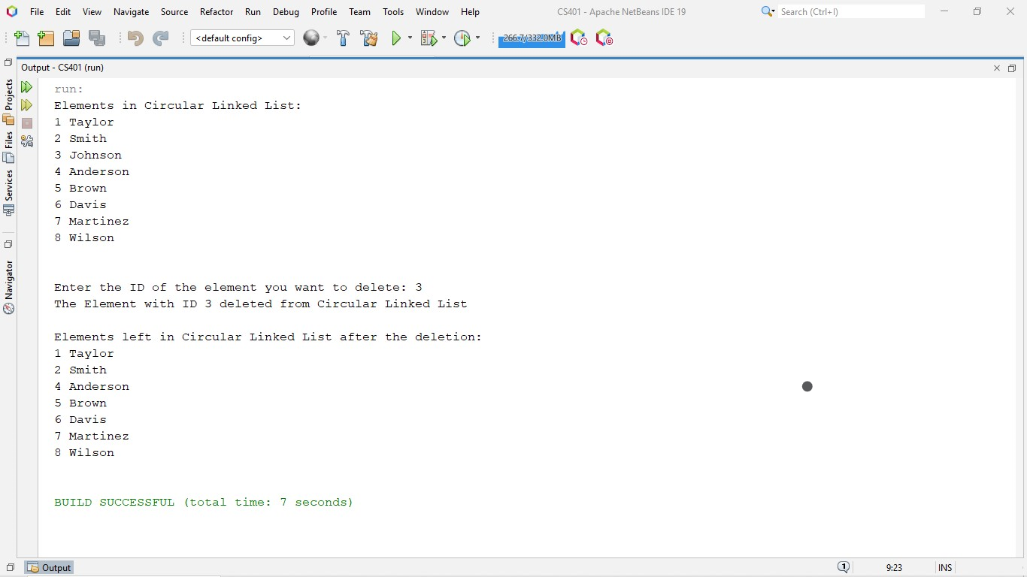

**Part 3**

Doubly linked list implementation with add, remove and contains methods

**Output**

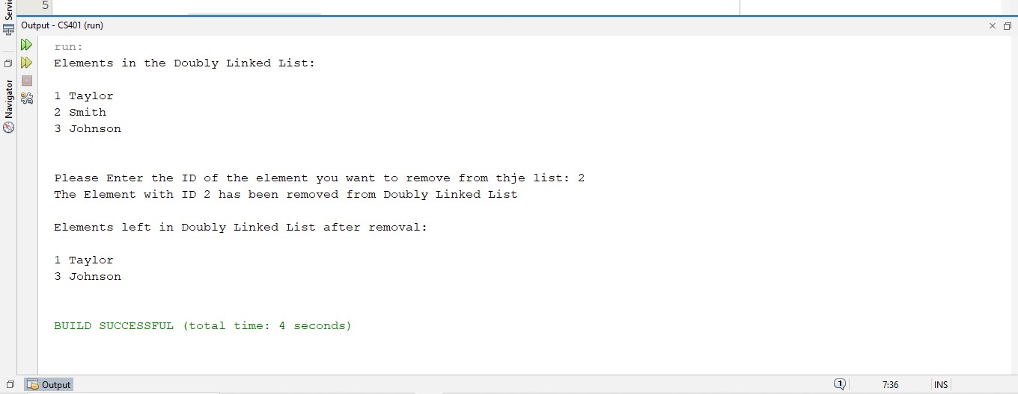

**Main.java program output**

This is the program that runs all other files

